Sheep Sale Market Report Saturday 2023 08 12

Fat Lambs:
Killough farmer 25.70kg £120.50, Ardglass farmer 32kg £119, Downpatrick farmer 26.40kg £118.50, Ballyhossett farmer 25.50kg £115.50, Downpatrick farmer 24kg £115, Ballynahinch farmer 26kg £115, Crossgar farmer 25.70kg £114, Comber farmer 25.70kg £113.50, Greyabbey farmer 25kg £112.50 and Ballyculter farmer 23.70kg £112.50.

Store Lambs:
Drumnaquoile farmer 19kg £101, Downpatrick farmer 19kg £86, Drumaroad farmer 19.90kg £85, Ballynahinch farmer 20kg £84, Drumaroad farmer 19.30kg £83, Ballynahinch farmer 19.30kg £80.30, Lisburn farmer 18.70kg £80.50, Dromore 17.70kg £80.50, Lisburn farmer 18kg £78.50, Downpatrick farmer 17kg £78 and Drumnaquoile farmer 18.40kg £78.

Fat Ewes:
Saintfield farmer £200, Moneylane farmer £193, Ballynahinch farmer £192, Downpatrick farmer £190, Downpatrick farmer £184, Moneylane farmer £183, Ballynahinch farmer £183, Ballyhossett farmer £171, Crossgar farmer £170 and Ballyhossett farmer £170.

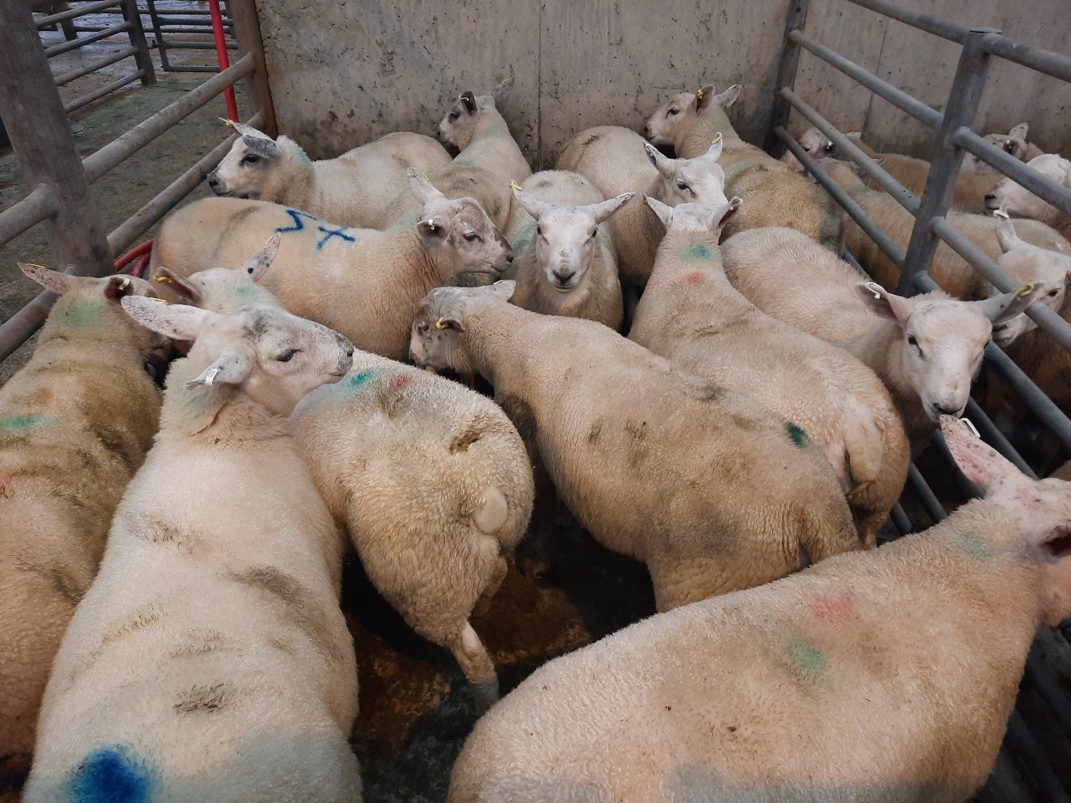
Killough farmer topped the fat lamb category on the day with Lot 57: 25.70kg at £101

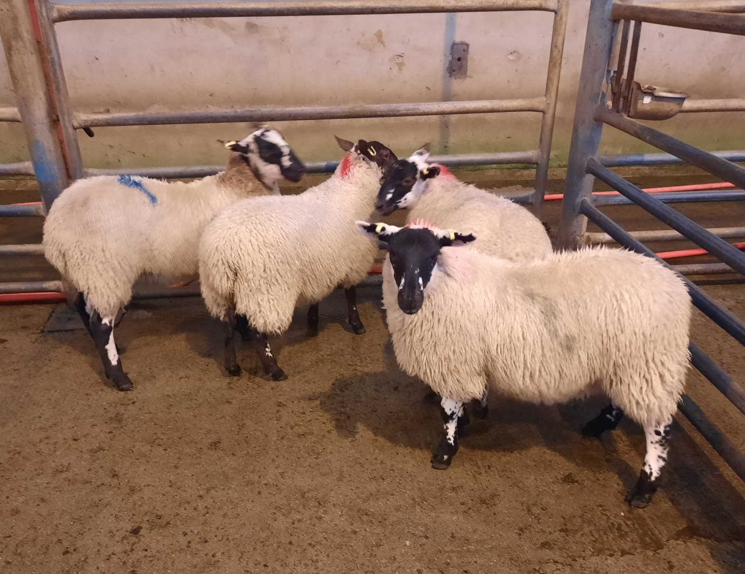
Drumnaquoile farmer topped the store lamb category on the day with Lot 9: 19kg at £101

